Salesforce External API Integration

Salesforce makes use of List Views to display records. An example of which is the Leads table.

List Views come with a pre-defined set of actions that can be applied to rows of data both individually and many at a time.

One such example is the Change owner action.

**Adding a Custom Action**

By using the Object Manager, one can modify the Lead record and add a custom action. We created a new action named Open Form.

When the user selects a row and clicks on the action button It opens a form with the data filled out

**Creating a Flow**

Salesforce allows us to define a sequence of steps using a Feature called Flows. Different operations can be defined in a flow such as fetching user data, taking form input, making API calls etc.

Once created the Flow can be added to a page or component such as a List View

**External API calls through Apex**

Another means of making calls to external APIs is through Salesforce Apex a SaaS framework.

One must define External Credentials and the schema and authentication details before being able to make calls to the API.

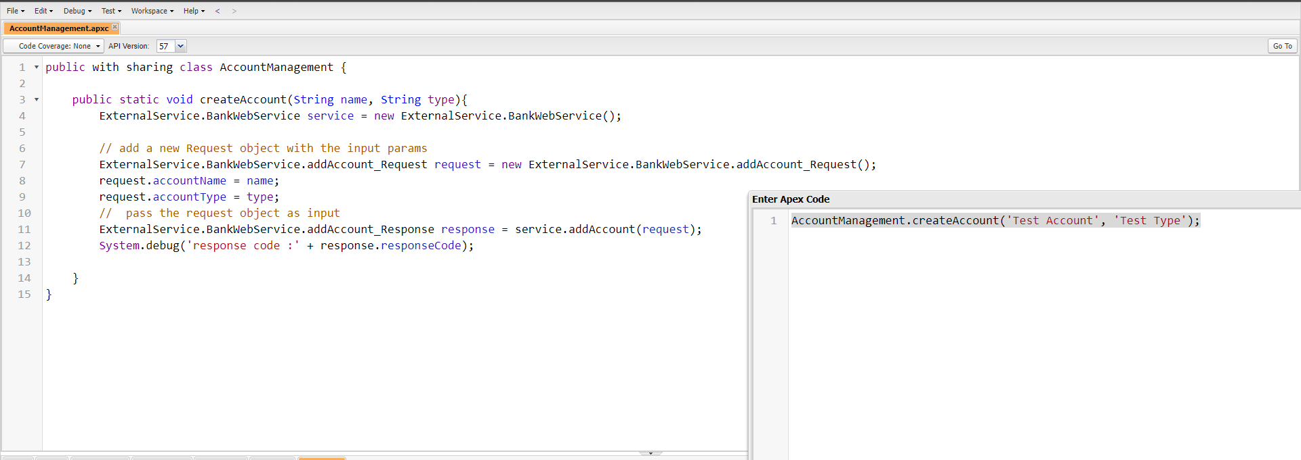The programming logic must be written in Apex.